EXPERIMENT 4
DATA VISUALIZATION
Aim
To visualize the Customer Churn dataset using Python by creating bar charts, pie charts, and line charts for better understanding of customer churn patterns.
Procedure
1. Import Pandas, Matplotlib, and Seaborn.
2. Load the Customer Churn CSV dataset.
3. Create a bar chart for churn by contract type.
4. Create a pie chart for churn distribution.
5. Group data by tenure and calculate average monthly charges.
6. Create a line chart for average monthly charges by tenure.
7. Add suitable titles and axis labels.
8. Display the visualizations.
Python Code
import pandas as pd
import matplotlib.pyplot as plt
import seaborn as sns

# Load dataset
df = pd.read_csv("WA_Fn-UseC_-Telco-Customer-Churn.csv")

# 1. Bar Chart - Churn by Contract
sns.countplot(x="Contract", hue="Churn", data=df)
plt.title("Customer Churn by Contract Type")
plt.xlabel("Contract Type")
plt.ylabel("Number of Customers")
plt.xticks(rotation=20)
plt.show()

# 2. Pie Chart - Churn Distribution
churn_count = df["Churn"].value_counts()

plt.pie(churn_count, labels=churn_count.index, autopct="%1.1f%%")
plt.title("Customer Churn Distribution")
plt.show()

# 3. Line Chart - Tenure vs Monthly Charges
df.groupby("tenure")["MonthlyCharges"].mean().plot(
kind="line", marker="o"
)

plt.title("Average Monthly Charges by Tenure")
plt.xlabel("Tenure (Months)")
plt.ylabel("Average Monthly Charges")
plt.grid()
plt.show()
- Output
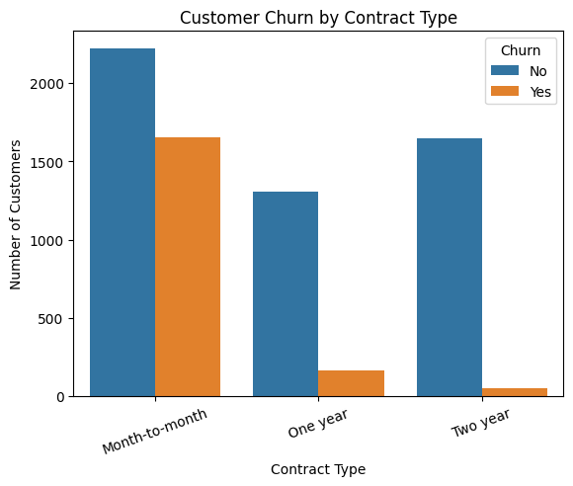
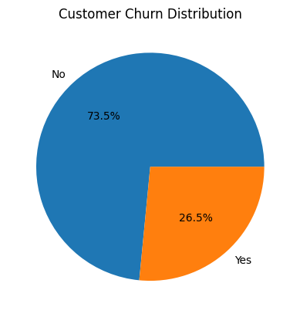
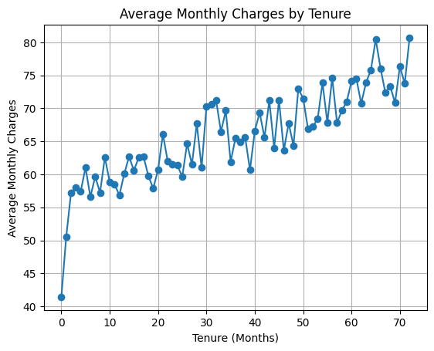

Result
The Customer Churn dataset was successfully visualized using bar, pie, and line charts. The visualizations helped identify churn patterns across contract types and understand the relationship between customer tenure and monthly charges.

